Health Impacts of Climate Change in Canada, Ontario and York Region research document

Submitted by David Hawkins Nov 19, 2024 8:40pm

**Canada’s rapidly heating climate is threatening Canadians’ health. What can you do about it?**

[Canada’s climate is warming](https://www.canada.ca/en/environment-climate-change/news/2019/04/canadas-climate-is-warming-twice-as-fast-as-global-average.html) twice as fast as the global average due to greenhouse gas emissions of carbon dioxide, methane and nitrous oxide from human activity. Climate change harms the health of populations globally, in Canada, Ontario and increasingly in York Region..

Our daily living habits add to the critical climate situation we’re in. We can all make incremental improvements in how we travel, the food we consume, if we own one—how we heat our home. An increasingly effective option is to be objective about the facts, causes and impact of our climate’s revolt and speak up.

Read on for an overview survey of health assaults happening and expected on Earth and York Region today and to come.

More annual extreme heat and extreme cold days impact our physical security directly. Higher incidence of heat stroke and heat exhaustion require emergency medical intervention, poor air and water quality take their toll on our battered breathing. More severe floods erode our equilibrium and wash out our sense of personal control; aberrant frosts and extensive wildfires destroy food crops and forests; more foodborne illnesses, rising food insecurity, and greater numbers of new vector-borne diseases are being tracked and treated in our local public health units. These climate change induced consequences stem from the continued rise of temperatures in the planetary atmosphere, earth eco systems and oceans. The largest contributor to that rise of these health outcomes is the producing, transporting and burning of fossil fuels.

**Extreme heat events**

The **Government of Canada**’s [attribution analysis](https://www.canada.ca/en/environment-climate-change/services/climate-change/science-research-data/extreme-weather-event-attribution.html#toc1) registered a spate of high temperatures across Canada this past summer. Among them heat waves in Eastern and Western Ontario in June through September 2024 lasted 2-to-ten days, and reached 6-to-10 degrees Celsius higher than normal **(normal=average of high temperatures observed from 1991-2020 in the month surrounding the heat wave, for that region)**. Environment and Climate Change Canada determined that these extreme events were “much more likely because of human influence on the climate.”

Chaotic climate events like rolling heat seas, marauding forest fires, draconian drought and floods compound the intensity of UV-B irradiation on plants, animals and humans. **Public Health** **Ontario** [estimates](https://www.publichealthontario.ca/en/Data-and-Analysis/Environmental-Health/Environmental-Burden-of-Cancer) between **2000-3,000 new cancers** a year result from exposure to UV radiation in sunlight.

The **federal government** [warns](https://health-infobase.canada.ca/datalab/heat-related-injuries-blog.html):

As our climate continues to change, [extreme heat events] are expected to become more severe…[H]otter extreme temperatures have been linked to an increase in the number of emergency department (ED) visits and hospital admissions, as extreme heat can exacerbate certain cardiovascular and respiratory diseases.

In **York Region** the incidence and prevalence of asthma among **seniors**, men and women 65+, is higher than the Ontario average. Among **school age pupils** the incidence and prevalence of asthma over 9 out of the ten years 2013-to-2022, is higher and rising more sharply than the Ontario average, higher too than for Toronto students.

A closer look at how York Region’s the 0-19 year-old demographic shows how our children, primary and secondary students’ [asthma prevalence](https://www.publichealthontario.ca/en/data-and-analysis/chronic-disease/chronic-disease-incidence-prevalence) compares.

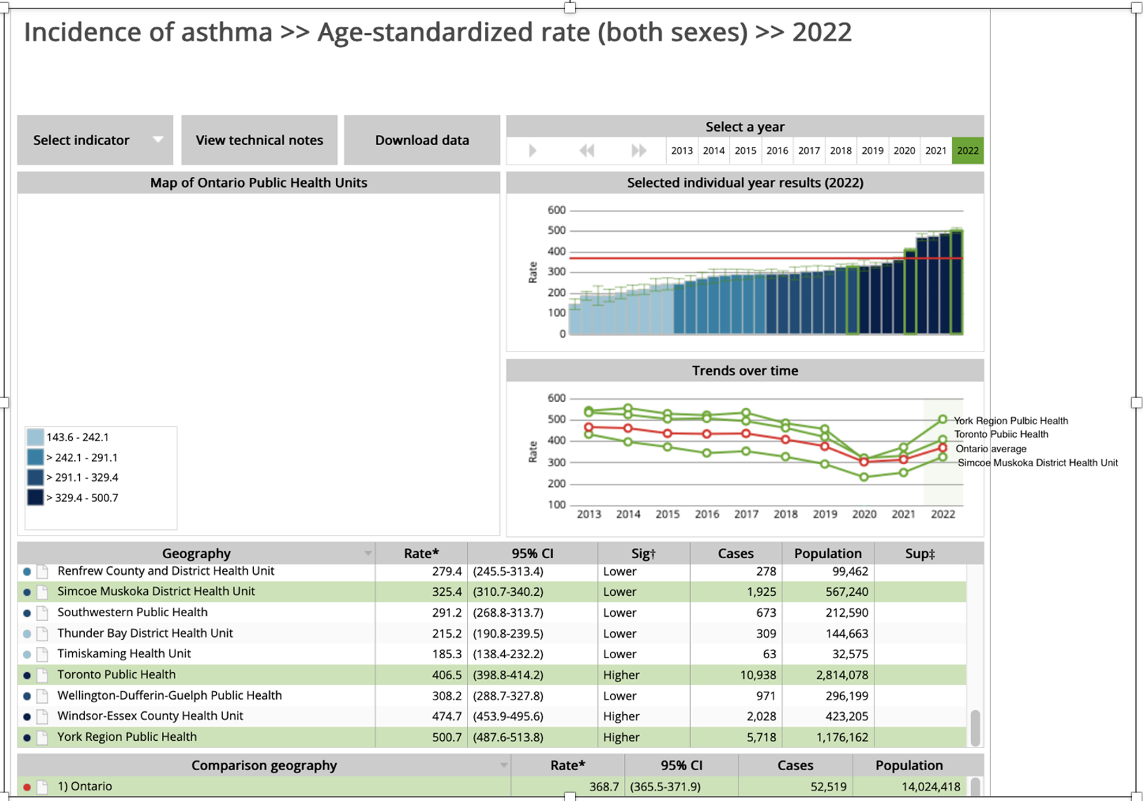

The **Canadian Centre for Occupational Health and Safety** [cautions](https://www.ccohs.ca/oshanswers/chemicals/diesel_exhaust.html#section-2-hdr)

Breathing in diesel exhaust can cause lung irritation and/or an allergic reaction causing asthma (wheezing and difficult breathing), or making pre-existing asthma worse.

**World Health Organization**’s Health Effects of Black Carbon study [concludes](https://wedocs.unep.org/handle/20.500.11822/8699):

Epidemiological studies provide sufficient evidence of the association of cardiopulmonary morbidity and mortality with exposure to **black carbon**. Toxicological studies suggest that black carbon may operate as a universal carrier of a wide variety of chemicals of varying toxicity to the human body.

The **World Bank** cites concern about black carbon plus and other chemicals in diesel emissions and[informs](https://www.worldbank.org/en/news/feature/2014/04/29/cleaning-up-diesel-exhaust-improves-health-climate):

Diesel engine exhaust has long been known to promote cardiovascular disease and lung cancer. A new understanding of one of the components of diesel exhaust [**black carbon**,] shows it is also a powerful driver of climate change, with black carbon particles 3,200 times more damaging to the climate than carbon dioxide in the near-term.

Notably, thousands of **York Region** pupils who ride daily on York Regional District and Catholic School Boards’ provided school buses, are exposed to **black carbon** and other dangerous particulate matter on their twice daily commute.

**Climate Change and future of food**

**Food borne illness**

Health Canada’s **“Health of Canadians in a Changing Climate”**[tells us](https://changingclimate.ca/site/assets/uploads/sites/5/2022/02/CCHA-REPORT-EN.pdf):

Precipitation, temperature, and extreme weather events are projected to increase the introduction of pathogens (viruses, bacteria, and parasites) to food, causing food-borne illness. Chemical contaminants that have harmful health effects may also be introduced into Canada’s food systems more frequently through various climate-sensitive environmental exposure pathways.

And

Climate change is affecting Indigenous food systems and contributing to declining availability,

accessibility, and quality of traditionally harvested foods, which play an important role in

community and individual health and well-being. **(p.539**)

**Food Insecurity**

The Doug Ford Government [supressed](https://www.cbc.ca/news/canada/toronto/ontario-climate-change-impact-assessment-1.6964662) its Provincial Climate Impact Assessment ([**PCCIA**](https://www.ontario.ca/files/2023-11/mecp-ontario-provincial-climate-change-impact-assessment-en-2023-11-21.pdf)), for seven months. Predictions are grim. It projects multiplying extreme heat days across Ontario, and more of both flooding and frequent wildfires.

It says although climate change may shift and extend growing seasons for farm produce

any potential opportunities are likely to be offset by negative impacts, resulting in declining productivity, crop failure, and livestock fatalities. Several commodities, particularly in the southern regions of the province, are expected to face ‘very high’ climate risks by the end of the century. **(p.xv)**

The food production outlook for Ontario’s most populous central, eastern and southwest areas according to the below PCCIA graphic does not look promising.

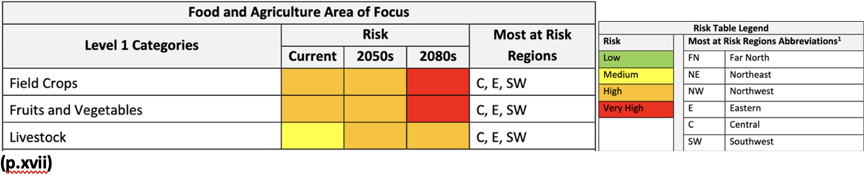

Health Canada’s report on impacts of Changing Climate [states](https://changingclimate.ca/site/assets/uploads/sites/5/2022/02/CCHA-REPORT-EN.pdf):

Climate change is increasing risks of food insecurity through disruptions to food systems, rises in food prices, and negative nutritional effects. **(p.539)**

“Social Determinants of Health—The Canadian Facts,” describes living with food insecurity:

Food insecure citizens are uncertain if they are able to acquire food in socially acceptable ways and is a barrier to adequate nutritional intake as they consume fewer servings of fruits and vegetables, milk products, and vitamins than those in food-secure households. **(p.34)**

Steep and rapidly rising food prices makes nutrition harder to come by. The **Canadian Community Health Survey**, says by 2022 **15.6%** of Canadian households [were experiencing](https://www150.statcan.gc.ca/n1/pub/82-003-x/2024010/article/00002-eng.htm) income related food insecurity.

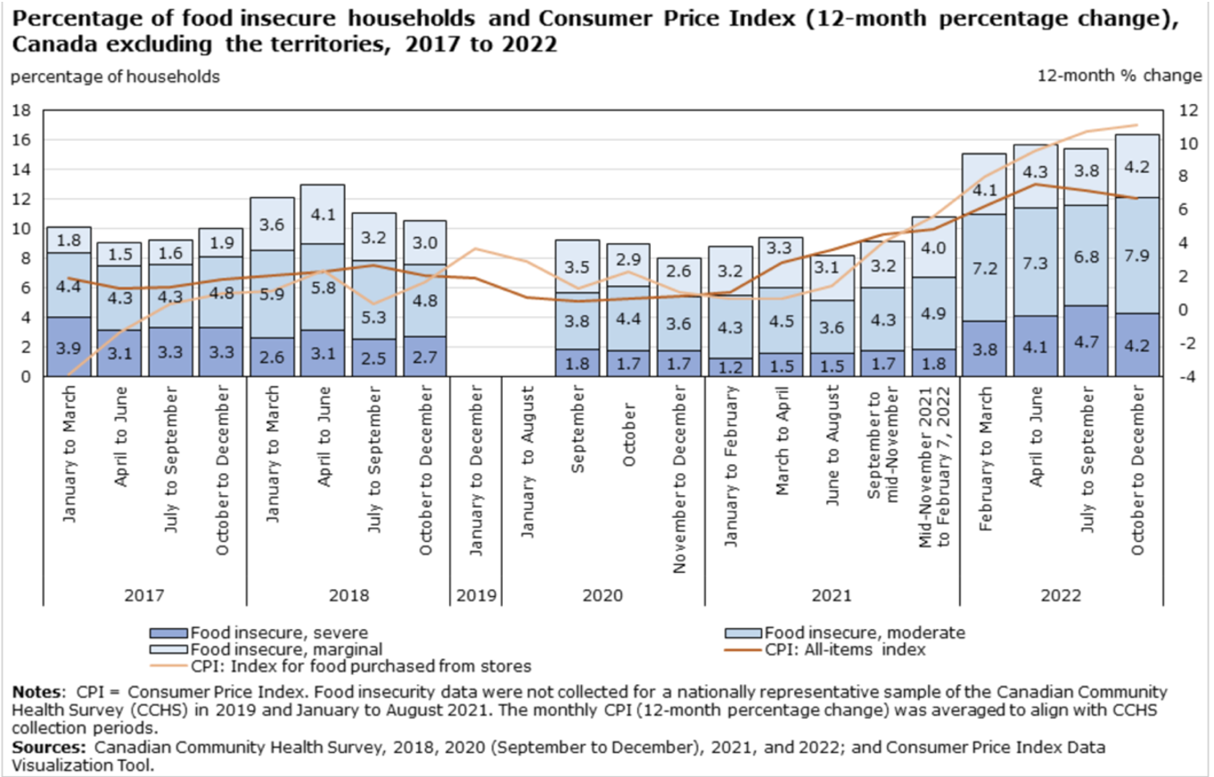

In **2018 Statistics Canada** [(shown here pg. 554)](https://changingclimate.ca/site/assets/uploads/sites/5/2022/02/CCHA-REPORT-EN.pdf) **reported 13.3%** of Ontarians experienced severe, moderate, or marginal food insecurity.

Health care cost for people who live with food insecurity is a continuing [social challenge](https://changingclimate.ca/site/assets/uploads/sites/5/2022/02/CCHA-REPORT-EN.pdf).

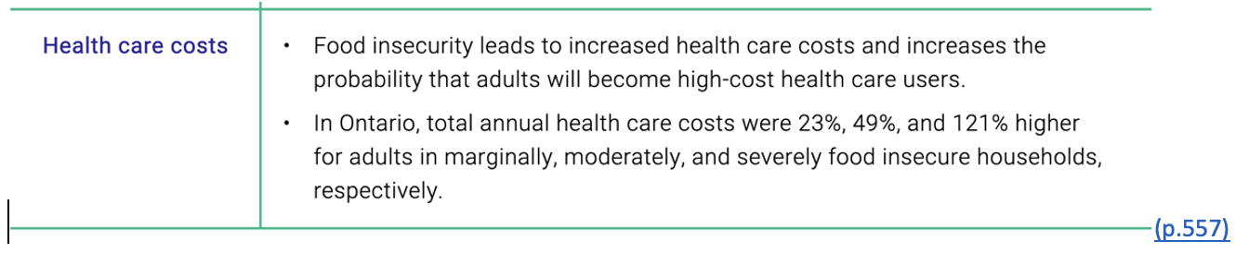

The Ontario 2023 **PCCIA** report [estimates](https://www.ontario.ca/files/2023-11/mecp-ontario-provincial-climate-change-impact-assessment-en-2023-11-21.pdf)

that one in six (**16.1%**) households in Ontario [is] food insecure…Low-income households, remote regions, and Indigenous Communities have been identified as those being at a disproportionate risk of food insecurity in Ontario. **(p.427)**

**Public Health Ontario** data **(graphic below)** **shows the average** percentage of food insecure households in the province **by 2022 was actually 17.4%**, about 2% above the Canadian average. Food insecurity in **York Region** has been sharply rising since the pandemic to **15.5**%.

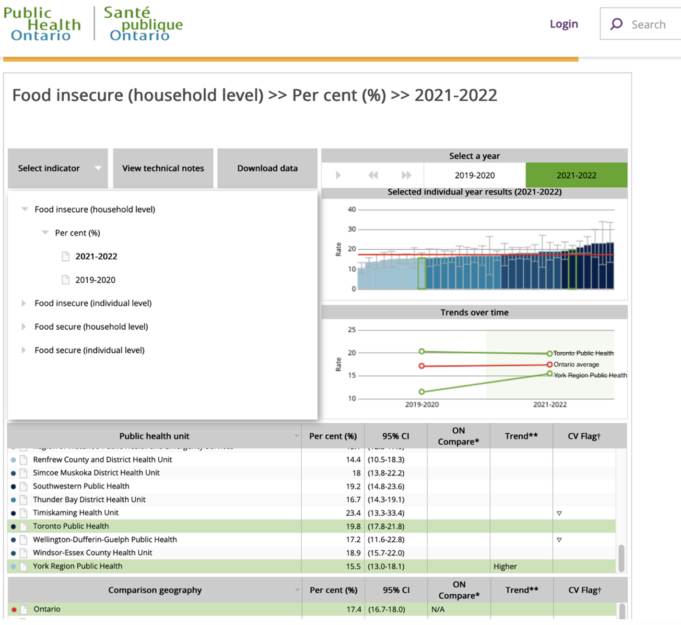

**Infectious (vector-borne) diseases**

Public Health Canada [considers](https://publications.gc.ca/collections/collection_2017/aspc-phac/HP5-122-2017-eng.pdf) the role global warming plays

as the underlying mechanism favouring the spread of tick-borne diseases, as climate will influence which tick species are found in a given geographic region, their population density, the likelihood that they will be infected with microbes pathogenic for humans, and the frequency of tick-human contact.

The black legged or deer tick, responsible for Lyme disease, is [found](https://www.publichealthontario.ca/-/media/Documents/O/2022/lyme-disease-risk-area-map-2022.pdf?sc_lang=en) all over York Region. Public Health Agency Canada [says](https://www.canada.ca/en/public-health/services/diseases/lyme-disease/surveillance-lyme-disease.html#a1) cases of Lyme disease often go under-reported. Three provinces are not included in this [national tally](https://www.canada.ca/en/public-health/services/diseases/lyme-disease/surveillance-lyme-disease.html#a1), but 2023 data estimates about 2,500 cases (short of the 2021 peak of 3,100) reported cases are rising steadily..

The Government of Canada Science Narrative [reports](https://publications.gc.ca/collections/collection_2017/aspc-phac/HP5-122-2017-eng.pdf)

climate change is likely to have both direct and indirect impacts on the burden of [these vector borne diseases] **West Nile fever, dengue, malaria, tick-borne encephalitis, Lyme disease, Yellow fever** **(p.4)**

**Waterborne disease**

How does climate change augment disease risk from water?

Climate change is providing favourable conditions for **algae and cyanobacteria** in ocean and freshwaters globally…Some species of freshwater cyanobacteria produce toxins (cyanotoxins) that are harmful to human health when ingested, leading to liver, skin, and nervous system toxicity. **(**[**p.488**](https://changingclimate.ca/site/assets/uploads/sites/5/2022/02/CCHA-REPORT-EN.pdf)**)**

…

In addition to more favourable conditions with warming waters, the increased surface runoff associated with extreme precipitation events can transport biological pathogens…, and also transfer nutrients into source water, promoting algal growth…Lake Erie, the shallowest of the Great Lakes, frequently experiences cyanobacteria blooms. [Health of Canadians in a Changing Climate](https://changingclimate.ca/site/assets/uploads/sites/5/2022/02/CCHA-REPORT-EN.pdf) **(p.489)**

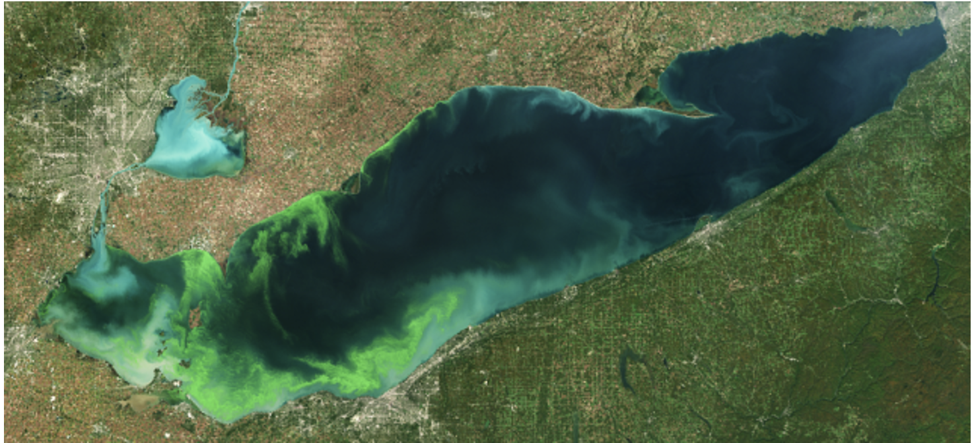

**A satellite image of a cyanoHAB -taken on October 8, 2022- in the western basin of Lake Erie. (Image credit: European Space Agency)**

A range of climate-sensitive pathogens or toxins currently affect the health of Canadians; these include algae, cyanobacteria, enteric viruses, and Leptospira, Leptonema, Vibrio, and Legionella bacteria. In addition, gradual warming and an increase in extreme events will continue to place stress on DWSs, potentially leading to the presence of biological or chemical agents in water, which could further lead to human exposure through drinking water, bathing, recreation, or ceremonial use **(p.521)**

Water borne, food borne and insect borne infections are Diseases of Public Health Significance in York Region and YR Public Health [provides](https://www.york.ca/newsroom/campaigns-projects/infectious-diseases-fact-sheets) information sheets on symptoms, treatment and prevention measures.

**Mental Health**

In a 2022 report Health Canada says that climate change [impacts on mental health](https://changingclimate.ca/site/assets/uploads/sites/5/2022/02/CCHA-REPORT-EN.pdf)

include disruptions to psychosocial well-being and resilience, disruptions to a sense of meaning in a person’s life, and lack of community cohesion. All of these can result in distress, higher rates of hospital admissions, increased suicide ideation or suicide, and increased substance misuse, violence, and aggression. Studies are also showing that people can become distressed about climate change itself, resulting in increased anxiety (often termed eco- or climate anxiety), grief (often termed eco-grief or climate grief), worry, anger, hopelessness, and fear.

and lead to

increased levels of PTSD, general distress, depression, and anxiety among flood survivors…Even people who are indirectly exposed to climate-related hazards can experience poor mental health outcomes, including vicarious trauma, secondary stress, and/or compassion fatigue for those whose lives have been disrupted by extreme events. **(p.26)**

A national climate-emotions survey [found](https://www.sciencedirect.com/science/article/pii/S2667278223000032?__cf_chl_tk=oPLy_AB_EMRdkGMkRKJHdud0vc7QgwVyMyXi.H2VOb0-1731711127-1.0.1.1-nfogeThSs1PMJmKoByo9Ju2ShVuuP_bpkkF8VuX1tu8) young Canadians

have contributed the least to the crisis, they are and will be disproportionately impacted, and they have limited opportunities and invaluable perspectives for influencing action. Evidence increasingly illustrates that young people are particularly vulnerable to climate distress and anxiety.

and

Concerningly, our data illustrate that the climate crisis is impacting the overall mental health and daily functioning of young Canadians: 8 in 10 reported that climate change impacts their overall mental health and 4 in 10 reported that their feelings about climate change negatively impact daily functioning. **(Version of Record 24 January 2023)**

In its [Climate Change and Health Vulnerabilty Assessement](https://www.york.ca/newsroom/campaigns-projects/climate-change-and-health), **York Region** predicts

Climate change is likely to have significant negative effects on mental health and well-being, especially for vulnerable populations and those with pre-existing mental illnesses.

and

mental health issues have been increasingly observed across York Region services, with a **40% increase** in mental health-related calls to the York Region Police and York Region Paramedic Services between 2012 and 2016. **(pp.50-51)**

We all witness the suffering climate change brings either to family or to populations near and far. Every one of us can make a difference if we choose to do so. Learn and critically think about your political representatives’ intentions for mitigating risks to property, health, wellbeing; after all we pay them for their service to us. When they ask for your vote you might want to ask their plans and strategies for adaptation and mitigation solutions towards securing our more confident and secure climate future. And then vote accordingly. To ignore the problems of higher heat, more drought, hurricanes, fires, and an arms-length list of health threats, is a choice. How will you justify yours to the next generation? They already know what’s going on and who’s taking responsibility. Or not.

XXX